Question 3 – (c)

Here are presented the snapshots of the calibration process.
- First, the images of the checkerboard plane have been taken from various camera poses. The camera used is the Huawei P9 dual-lenses camera. Thus, in order to keep the process authentic, one of the lenses was covered. Each of the corners was marked by a number for a more convenient calibration process.
Figure 1 : the camera used in the calibration process
- Following the instructions, the images are being uploaded into the calibration program:

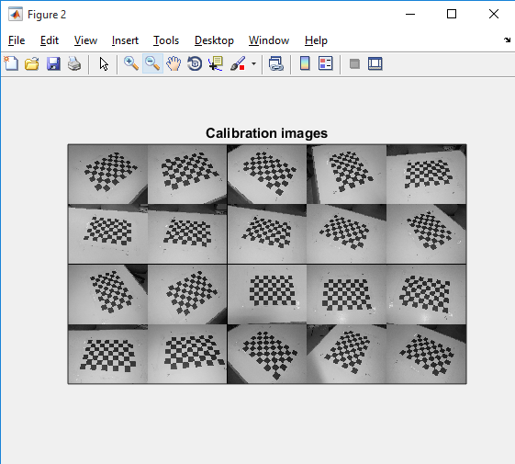

- Corner extraction of the images, repeated on all the images
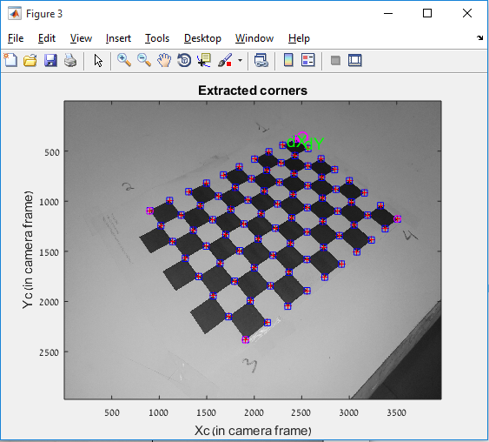

- Calibration parameters are obtained:

Focal Length: fc = [ 3189.24204 3189.24204 ]
Principal point: cc = [ 1983.50000 1487.50000 ]
Skew: alpha_c = [ 0.00000 ] => angle of pixel = 90.00000 degrees
Distortion: kc = [ 0.00000 0.00000 0.00000 0.00000 0.00000 ]

Main calibration optimization procedure - Number of images: 19
Gradient descent iterations: 1...2...3...4...5...6...7...8...9...10...11...12...13...14...15...16...17...18...19...20...21...done
Estimation of uncertainties...done

Calibration results after optimization (with uncertainties):

Focal Length: fc = [ 3020.08805 3056.13647 ] +/- [ 39.75145 35.31200 ]
Principal point: cc = [ 1999.65339 1592.93877 ] +/- [ 9.42775 35.21215 ]
Skew: alpha_c = [ 0.00000 ] +/- [ 0.00000 ] => angle of pixel axes = 90.00000 +/- 0.00000 degrees
Distortion: kc = [ 0.10233 -0.31015 -0.00415 0.00271 0.00000 ] +/- [ 0.00874 0.03295 0.00096 0.00121 0.00000 ]
Pixel error: err = [ 1.41622 1.74597 ]

- The reprojection error looks quiet large:

Our aim is to decrease it to the biggest scale.

- Using the Recomp.corners function provided in the GUI, a new calibration is performed, resulting in the following calibration results:

Calibration results after optimization (with uncertainties):

Focal Length: fc = [ 3043.25574 3075.15744 ] +/- [ 28.86633 26.23904 ]
Principal point: cc = [ 2000.49865 1569.94521 ] +/- [ 7.74148 24.72921 ]
Skew: alpha_c = [ 0.00000 ] +/- [ 0.00000 ] => angle of pixel axes = 90.00000 +/- 0.00000 degrees
Distortion: kc = [ 0.12149 -0.40301 -0.00409 0.00292 0.00000 ] +/- [ 0.00753 0.02930 0.00080 0.00097 0.00000 ]
Pixel error: err = [ 1.20546 1.47363 ]

It may be observed that the Pixel error has decreased in comparison to the first calibration results.

The reprojection error has decreased as well:
- Analyzing some of the critical errors (in teal color in the the reprojection error graph):

Pixel error: err = [ 1.20546 1.47363] (all active images)

Selected image: 17
Selected point index: 11
Pattern coordinates (in units of (dX,dY)): (X,Y)=(0,6)
Image coordinates (in pixel): (3746.05,1726.11)
Pixel error = (5.61498,2.11331)
Window size: (wintx,winty) = (5,5)

As it may be seen, image 17 was not processed in a correct way, perhaps the corners were poorly extracted. By checking the image, it is validated:

Using a larger values for wintx and winty parameters should help to increase the ability to find the problem.
By using the values $\left\{\begin{aligned}wintx=8 \\ winty=8\end{aligned}\right.$ , the following performance improvement is noticed:
By looking at numerical representation of the calibration, it is obtained:

Calibration results after optimization (with uncertainties):

Focal Length: fc = [ 3064.80707 3093.11220 ] +/- [ 24.15153 22.46772 ]
Principal point: cc = [ 1999.02148 1548.76380 ] +/- [ 7.03138 19.94824 ]
Skew: alpha_c = [ 0.00000 ] +/- [ 0.00000 ] => angle of pixel axes = 90.00000 +/- 0.00000 degrees
Distortion: kc = [ 0.13995 -0.49685 -0.00421 0.00270 0.00000 ] +/- [ 0.00721 0.02887 0.00074 0.00086 0.00000 ]
Pixel error: err = [ 1.09649 1.41861 ]

- Visualizing the distortions creates the following plots. The guess is that indeed, since the smartphone possesses two cameras, the distortion is “shifted” away from the second camera, so that together they create a full “symmetric” distortion model.

- Using one of the images, the extrinsic parameters were also calculated:

Extrinsic parameters:

Translation vector: Tc_ext = [ 157.196418 -33.157908 330.557975 ]
Rotation vector: omc_ext = [ 0.919513 -2.736548 0.820951 ]
Rotation matrix: Rc_ext = [ -0.803385 -0.594159 0.039334
-0.517696 0.664303 -0.539160
0.294217 -0.453516 -0.841285 ]
Pixel error: err = [ 1.70132 1.94694 ]

Question 3 – (d)

By taking the data provided by the toolbox in the previous section of the question, the calibration matrix K is obtained: (values are shortened up to the natural number)

$$K=\left[\begin{matrix}f_{x} & s & u_{0} \\ 0 & f_{y} & v_{0} \\ 0 & 0 & 1\end{matrix}\right]=\left[\begin{matrix}3065 & 0 & 1999 \\ 0 & 3093 & 1549 \\ 0 & 0 & 1\end{matrix}\right]$$

If, for example, we use the image that the extrinsic parameters were extracted for (Question 3 (c) – 9), we obtain the following projection matrix:
$$K \left[ R \right| t]= \left[\begin{matrix}f_{x} & s & u_{0} \\ 0 & f_{y} & v_{0} \\ 0 & 0 & 1\end{matrix}\right]\left[ R_{3×3} \right| t_{3×1}]=$$
$$= \left[\begin{matrix}3065 & 0 & 1999 \\ 0 & 3093 & 1549 \\ 0 & 0 & 1\end{matrix}\right]\left[\begin{matrix}-0.803385 & -0.594159 & 0.039334 & 157.196418 \\ -0.517696 & 0.664303 & 0.039334 & -33.157908 \\ 0.294217 & -0.453516 & -0.841285 & 330.557975\end{matrix}\right]=M_{3×4}$$

$$M_{3×4}=\left[\begin{matrix}-1874.23 & -2727.67 & -1561.17 & 1142592.4 \\ -1145.49 & 1352.19 & -1181.49 & 409476.89 \\ 0.294 & -0.4535 & -0.8412 & 330.55\end{matrix}\right]$$

This matrix M is unique for each of the images, since the extrinsic parameters do change for every camera pose.

